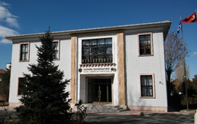

Vision
Our vision is to become a pioneer faculty depending on the policy and revolutions of the Republic of Turkey that uses artistic and scientific knowledge for the benefit of humanity, consider the universal level of thinking, give a direction of studies in cultural heritage, museology and art.
Mission
Our mission of is to train qualified individuals who are with aesthetic precision and able to develop their creative strength and intuitions in the undergraduate and graduate levels, perform research, discovery, application, testing and checking processes through artistic and scientific methods.

About Us
Even though Ankara University Faculty of Fine Arts was established in 03.04.1997 unlike the other faculties in Turkey, it accepted the foundation of the Departments of Conservation and Restoration of Cultural Properties, Museology (subjects about cultural heritage) and Basic Art Training with Higher Education Board's decision dated 01.07.2015. The undergraduate programme of Conservation and Restoration of Cultural Property has been ready since February 2016 and was presented to Ankara University Senate Committee.

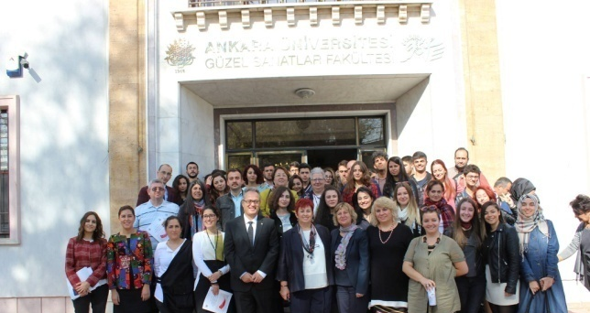

Turkey is known with the presence of a rich archaeological, ethnographical and plastic arts heritage. Each day the cultural heritage increases but because there is not enough hardware, professionals and academicians who can work in cultural heritage discipline, it has been decided to establish the programme preferentially.

There are two professors, two associate professor, four assistant professors, four research assistants, nine lecturers including two from conservation and restoration, one from music, three from paintings, one from art education and two from sculpture designing in Ankara University Faculty of Fine Arts.

There are painting, stone, mosaic – wall painting, ceramics – glass, textiles, paper, chemistry conservation and restoration laboratories and material analysis laboratory in our faculty. In addition to that, a specialized library in conservation – restoration, museology and arts field is opened with the reading room for all researchers and students.
Information about Programmes
Undergraduate Programme of Conservation and Restoration of Cultural Property is designed as a four-year degree program. Programme accepted 41
students with Undergraduate Placement Examination in 2018 – 2019 academic year. Graduate Programmes which are considered as necessary for Turkey in Conservation and Restoration of Cultural Heritage and Museology are also planned to be put in operation. Preparations of the opening of the several art programmes as Painting, Sculpture, Graphics, Ceramics and Art Management etc. are underway in the future.

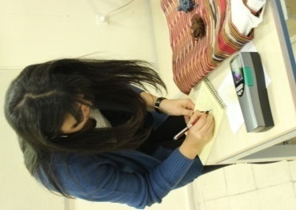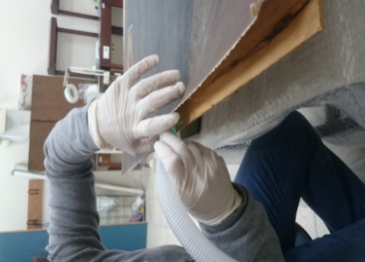

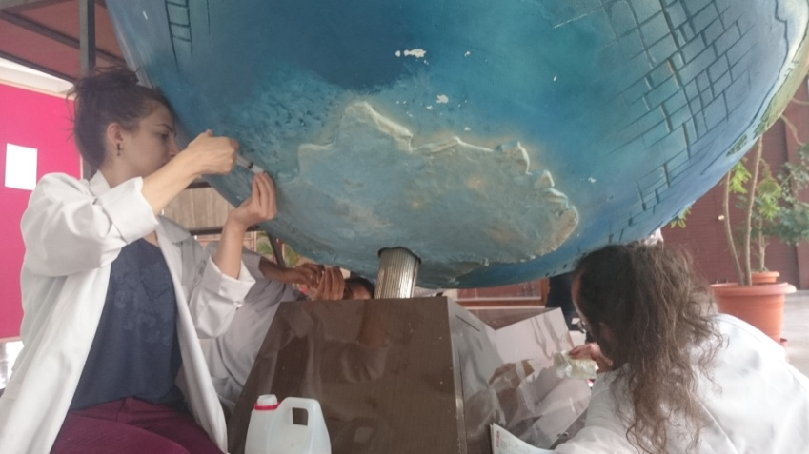

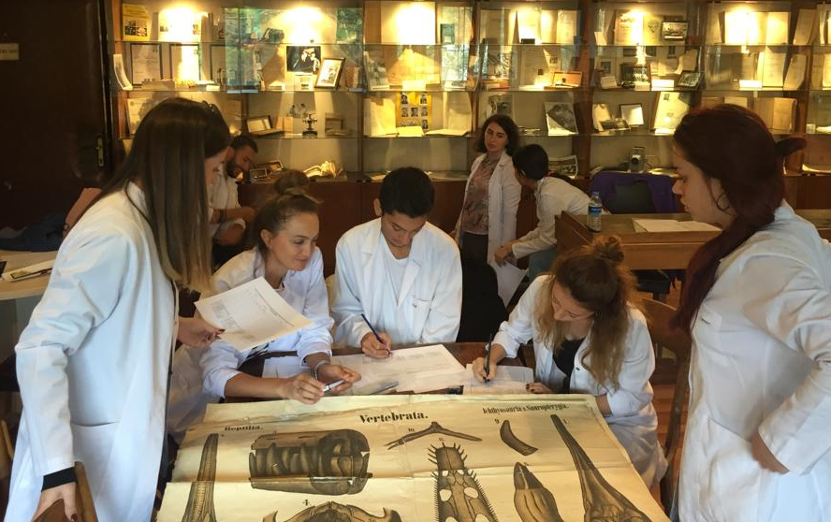

Ankara University Fine Arts Faculty
Ankara Üniversitesi Gümüşdere 60. Yıl Yerleşkesi Fatih Caddesi No: 33/A Keçiören/Ankara/Türkiye

E-mail: guzelsanatlar@ankara.edu.tr
Phone:0 (312) 316 49 20
Fax: 0 (312) 316 49 03
Web: http://www.gsf.ankara.edu.tr
https://www.facebook.com/GSF.ankara.edu.tr/?fref=ts#
gsfankara@outlook.com

